With the emergence of Covid-19, countries have introduced tracking and control measures that may intrude on individual privacy. Looking ahead to future crises, how should countries approach public health needs vs. those of personal privacy?

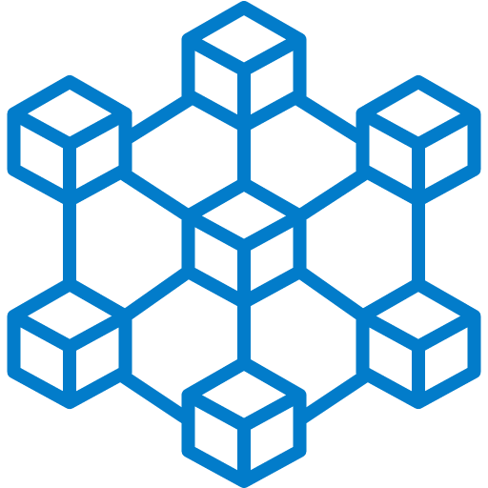

At its core, a blockchain is a decentralized digital ledger. We use blockchains to store and verify data, which no one can forge or manipulate. It provides transparency to government/ company actions and reduces transit of defective or fake goods. Inside of blockchains, we can create smart contracts. Smart contracts are programs stored on a blockchain and ran when planned conditions are met. They can be created on any blockchain that supports smart contracts. Some include Ethereum, hyperledger, polkadot... Cryptography can be used to protect an individual's privacy. Countries can distribute & track resources effectively while safeguarding individual privacy using blockchain while creating and eliminating careers.

Proper supply chain management is needed to ensure public health satisfaction. In a crisis, some countries may have a surplus of items, while others have none. Governments can work together to distribute items equally using blockchains. Smart contracts can manage the flow of supplies based on the severity of a country's situation, the amount of money chipped in, and their collection. Let's say the Canadian government orders 15 million vaccine doses for $220 million. This transaction is saved on the blockchain. Suddenly, Canada announces that it won't need 10 million doses as most Canadians are fully vaccinated. Once an oracle validates this message, the smart contracts note the availability of 10 million doses. A few weeks later, Liberia orders 10 million doses for $147 million. This transaction is processed and validated in seconds using smart contracts. Money is stored inside the smart contract until electronic tags confirm that all products have arrived at their intended destination. Once all doses arrive in Liberia, the smart contract sends all funds to the Canadian government.

Blockchain is a public ledger that everyone has access to and can view at any time. This causes concern for people's privacy. Our solution would be to provide everyone with a public key and a private key. Think of a public key as a username and a private key as a password, not stored on any centralized servers. Public-private keys lessen cyber attacks and give complete control to a person's account. When an individual's data is uploaded to a blockchain, their identity is hidden to the public behind a randomized 64 digit character. This number conceals their identity while allowing them to provide factual data to the blockchain. So how can this work in the real world? Let's say you're the premier of Ontario, and you need to provide a vaccination status report to the Federal government. By issuing everyone a public-private key, they can upload their current vaccination status onto the blockchain. Using smart contracts, whenever individuals try to upload anything to the blockchain, they will need a certified governmental official to input their private key to validate any uploaded data. This system secures the blockchain from false data/ accounts.

As of right now, we discussed how countries could use the blockchain to approach public health needs while concealing an individual's privacy. However, how can we encourage citizens to use blockchains? The answer is simple, by providing incentives. On Bitcoin's blockchain, people receive bitcoin for mining. Miners can keep or exchange their bitcoins for cash. The same concept can be applied to countries and their citizens. Whenever a citizen or a government contributes data to a blockchain, they receive coins that can be held or traded. These incentives push people to upload data onto the blockchain, allowing governments to use this information to manage crises.

So you may ask yourself, how will blockchain affect the job market? It depends on which industry. Countries will need programmers with the increased use of blockchains in non-technological sectors such as supply chain management and healthcare. Blockchain developers, data scientists, machine learning, security, and encryption specialists will be needed to normalize blockchain. However, many careers are at risk. One of the primary use cases for blockchain technology is to eliminate intermediaries. In our case, third-party supply chain management verifiers, signees, and project managers will be at risk of being replaced by blockchain technology. Therefore while blockchain can create new careers, it eradicates many third parties.

In conclusion, blockchains will help governments solve global problems. Blockchains provide data from citizens while keeping anonymity. To encourage countries & citizens to adopt blockchains, we incentivize them with coins. People receive incentives for contributing, and the government uses data to solve world problems. Furthermore, while blockchains will create new careers, some will be eradicated. Nevertheless, blockchains will soon influence our daily lives in one way or another.